A Practical Activity Report

Submitted for Engineering Design III (UTA-011)

Submitted By:

Satvik Singh 101603307

Submitted To: Dr. Kunal Singh



Electronics and Communication Engineering Department

Thapar Institute of Engineering and Technology,

Patiala-147004,

Punjab,

India

Jan-June 2018

**Experiment 1**

**Objective:**

(a) To draw a schematic diagram of pulse width modulation (PWM) based receiver to receive IR signals from gantries connected to transmitter circuit using CAD tool (Eagle)

(b) To design a printed circuit board layout of pulse width modulation(PWM) based receiver circuit using CAD tool(Eagle).

**Software Used:** Eagle software

**Component Used:**

|  |  |  |  |
| --- | --- | --- | --- |
| **Serial No.** | **Component** | **Name** | **Value** |
| 1. | R1 | 120kΩ | 120kΩ |
| 2. | R2 | 100kΩ | 100kΩ |
| 3. | R3 | 22kΩ | 22kΩ |
| 4. | R4 | 1kΩ | 1kΩ |
| 5. | C1 | 100nF | 100nF |
| 6. | IC1 | Voltage comparator LM311D |  |
| 7. | D1 | Schottky diode MBD701 |  |

**Circuit Diagram:**

**Theory:**

1. **Resistors-**A resistor is a passive two-terminal electrical component that implements electrical resistance as a circuit element. Resistors are used to reduce current flow, adjust signal levels, to divide voltages.

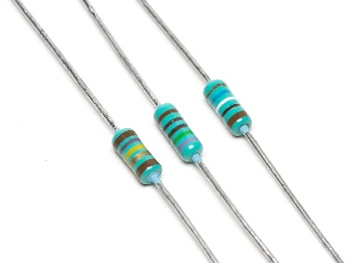

**Figure 1**

1. **Capacitors-**A capacitor is a passive two-terminal electrical componentthat stores electrical energy in an electric field.

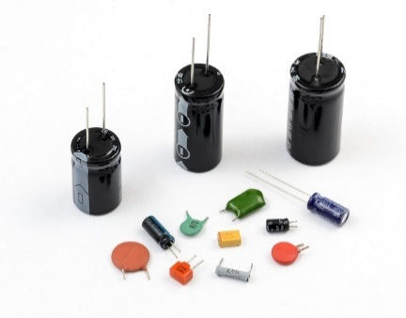

Figure 2

1. **MBD701–** (Schottky Barrier Diode) It is designed primarily for high−efficiency UHF detector applications. It is readily adaptable to many other fast switching RF and digital applications. They are supplied in an inexpensive plastic package for low−cost, high−volume consumer and industrial/commercial requirements

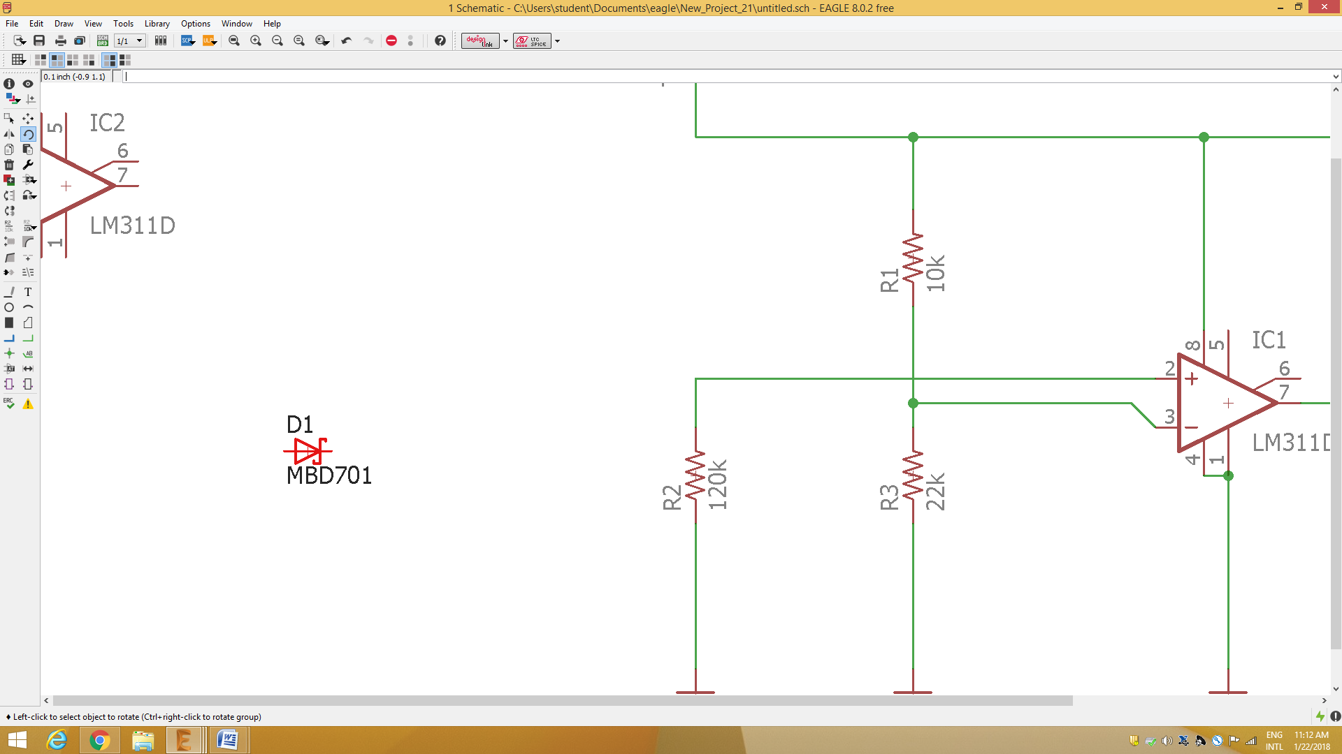

Figure 3

1. **LM311D-** LM311D are voltage comparators that have low input currents. They are also designed to operate over a wide range of supply voltages: from standard ±15V operational amplifier supplies down to the single +5V supply used for IC logic. Their output is compatible with RTL-DTL and TTL as well as MOS circuits and can switch voltages up to +50V at output currents as high as 50mA.

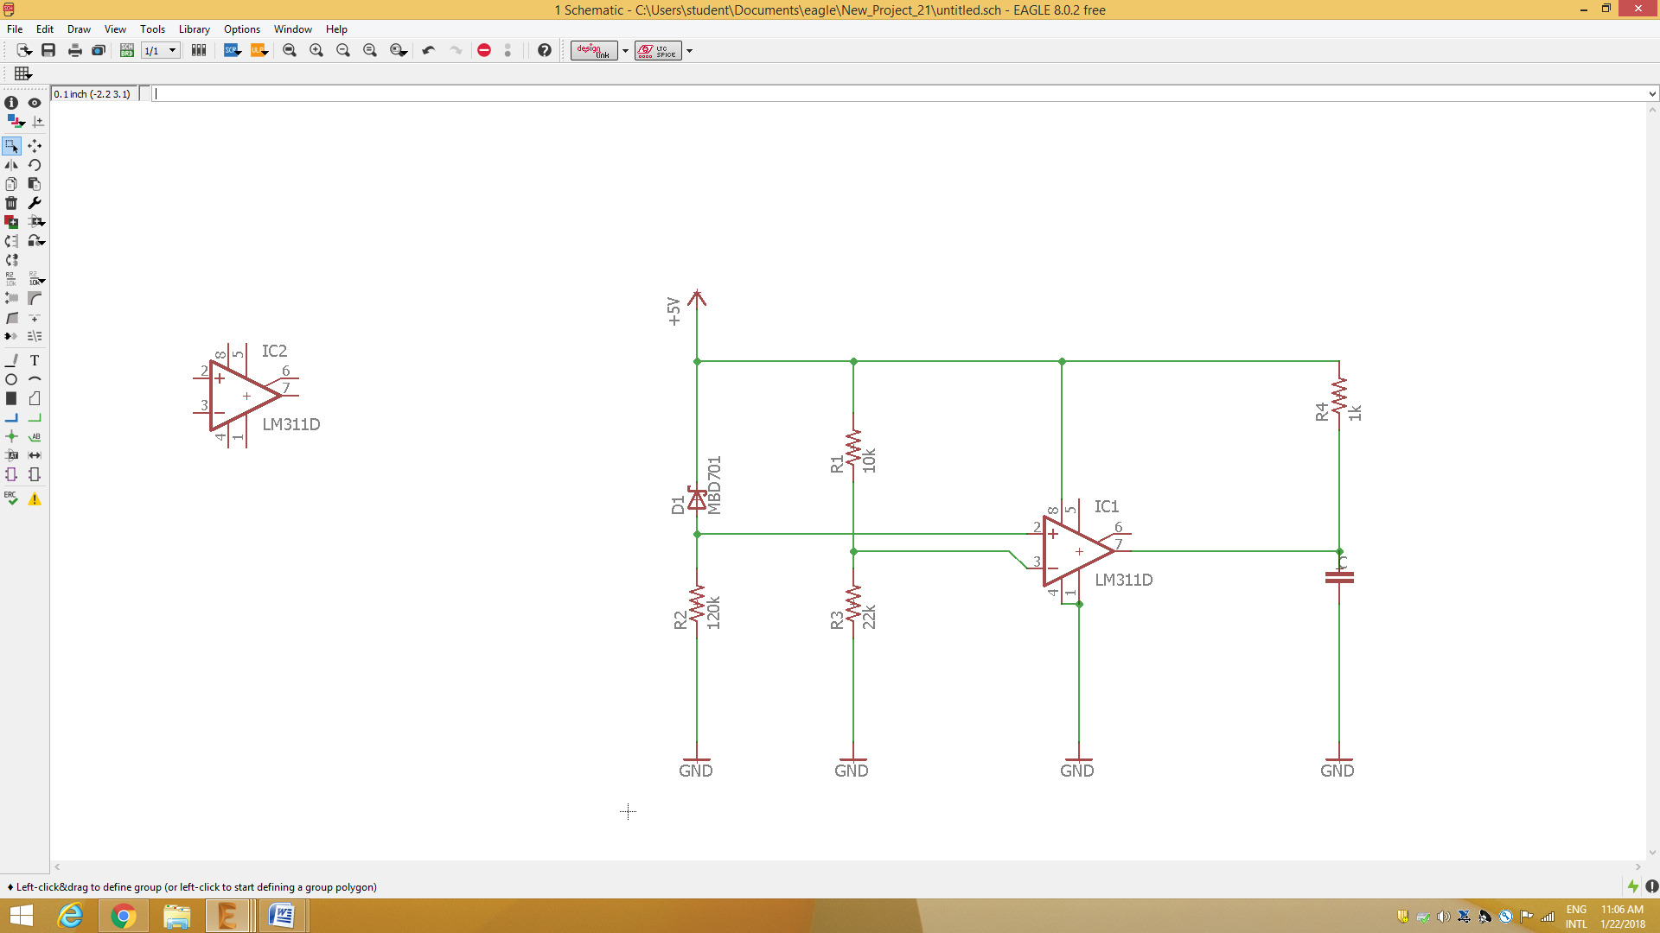

**Schematic Diagram:**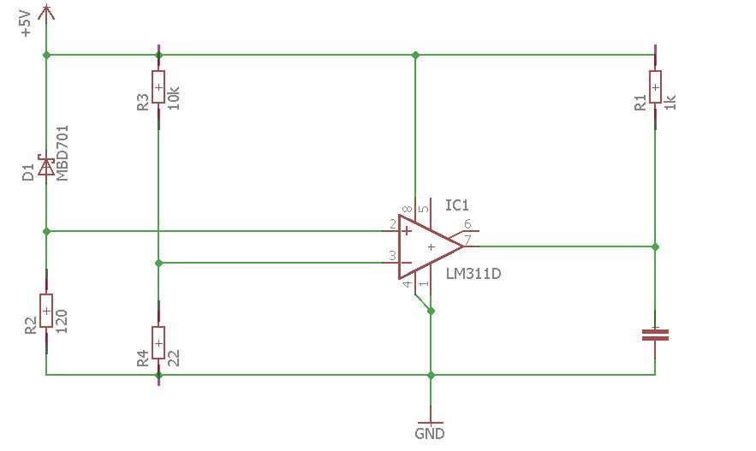

**PRINTED CIRCUIT BOARD LAYOUT**

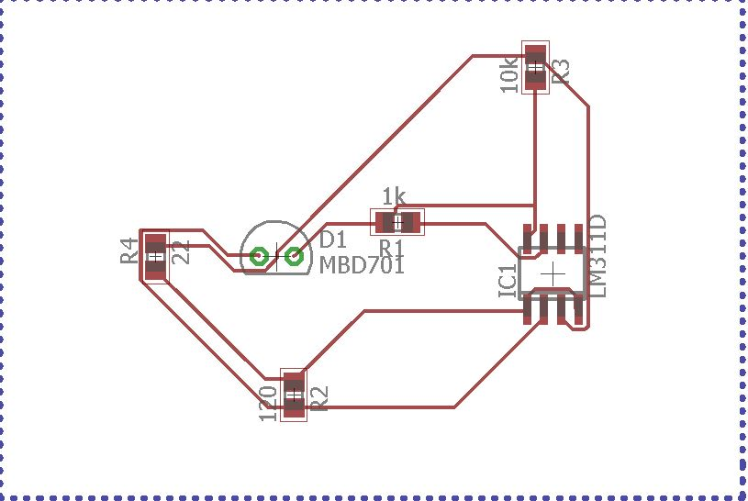

**Discussion:**

* In this experiment, we learnt about the components used in receiver circuit which we will use in our BUGGY Project.
* We drew the schematic diagram of receiver circuit using EAGLE software.
* We presented the schematic diagram on PCB using EAGLE software.

Signature: